**Professional Video Production in Chicago**

Chicago is a city known for its energy, creativity, and innovation, making it a hub for businesses and individuals seeking high-quality video production services. Whether you're a small startup or an established corporation, professional video production in Chicago can help you communicate your story effectively. From capturing your brand’s essence to creating content that resonates with your audience, video is a powerful tool to elevate your message and stand out in a competitive market**.**

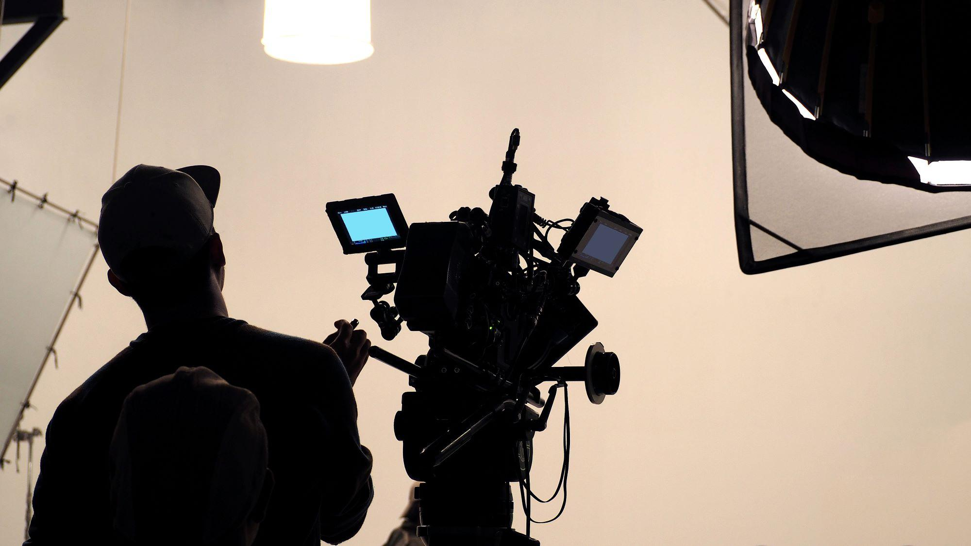

**The Value of Storytelling in Video Production**

In today’s digital world, storytelling is at the heart of impactful video production. People are drawn to authentic stories that evoke emotion and build connections. By investing in professional [video production in Chicago](https://creativesphere.co/service/video-production), you can ensure your story is told in a way that is visually compelling and meaningful. Whether it’s a promotional video, a product launch, or an employee spotlight, a well-crafted narrative can leave a lasting impression on your audience.

**Comprehensive Services for Every Need**

Video production in Chicago encompasses a wide range of services designed to meet diverse needs. At Creative Sphere Media, we provide everything from corporate videos and event coverage to drone videography and social media content. Our team handles every stage of the production process, including scriptwriting, filming, and editing, ensuring your project is executed seamlessly. No matter the scale or complexity, we deliver videos that align with your goals and capture your vision.

**Why Choose Creative Sphere Media**

Not all video production companies in Chicago are created equal. At Creative Sphere Media, we set ourselves apart by combining cutting-edge technology, industry expertise, and a passion for storytelling. We take the time to understand your unique needs and work collaboratively to create videos that reflect your brand’s values and resonate with your target audience. With a commitment to quality and creativity, we help you achieve results that truly make an impact.

**Elevate Your Brand with Professional Video Content**

In a city as vibrant as Chicago, having professionally produced videos is crucial for standing out. Video production goes beyond creating visuals—it’s about building a connection with your audience and conveying your message effectively. At Creative Sphere Media, we’re here to help you bring your ideas to life with high-quality, engaging video content that drives results. Let us partner with you to create videos that inspire, connect, and elevate your brand

#videoproductionchicago